ITSM

Asset Analysis
Report

Submitted By

Roshini Muthu

TABLE OF CONTENTS

S NO | DASHBOARD NAME | PAGE NO
 | Asset Overview & Inventory | 3
 | Financial Analytics & Trends | 5
 | Asset Health and Maintenance | 8
 | Security and Compliance | 10
 | Allocation & Verification | 13
 | Hardware Configuration & Performance | 16
 | Audit & Compliance Issues | 19
 | Executive Summary | 23

Asset Overview & Inventory
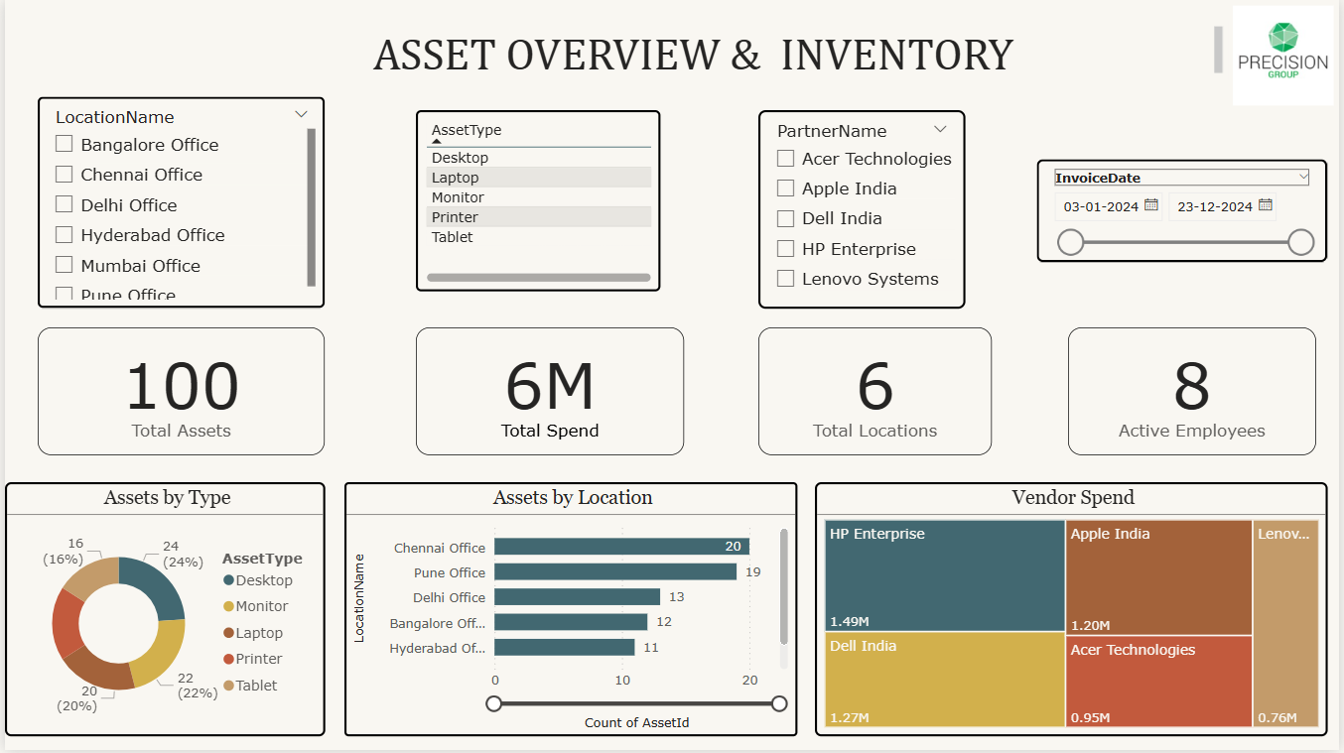

Summary Metrics
- Total Assets: 100 units
- Total Spend: 6 million
- Locations: 6 offices across India
- Active Employees: 8
- Tracking Period: December 23, 2024, to January 3, 2024

Key Visualizations

1. Assets by Type (Donut Chart) - Shows the proportional distribution of assets across different categories
- Desktop: 24% (24 units) - Largest category
- Tablet: 22% (22 units) - Second highest
- Laptop: 20% (20 units) - Mobile workforce support
- Monitor: 18% (18 units) - Display infrastructure
- Printer: 16% (16 units) - Smallest category
Insight: Balanced mix between traditional desktops and modern mobile devices (tablets/laptops), indicating a hybrid work environment.
2. Assets by Location (Bar Chart) - Illustrates the asset count distribution across various physical locations
Distribution:
- Pune Office: 20 assets (highest allocation)
- Chennai Office: 19 assets
- Delhi Office: 13 assets
- Bangalore Office: 12 assets
- Hyderabad Office: 11 assets (lowest allocation)
- Mumbai Office: Asset count visible but not specified.
Insight: Relatively even distribution with slight concentration in Pune and Chennai, suggesting these are primary operational hubs.

3. Vendor Spend (Tree map) - Visualizes the total spend allocated to different vendors, with size representing the magnitude of expenditure
Vendor Allocation:
- HP Enterprise: ~1.68M (28% - largest vendor)
- Apple India: ~1.20M (20%)
- Acer Technologies: ~0.95M (16%)
- Lenovo Systems: ~0.76M (13%)
- Dell India: ~0.52M (9%)
Insight: Multi-vendor strategy with HP as the primary partner, ensuring supply chain diversification and competitive pricing.

4. Asset Type Table – Slicer
Purpose: A detailed table view, likely showing a breakdown of assets by type and associated details
Function: Provides granular data for each asset category including specifications, quantities, and potentially procurement details.

Strategic Analysis
- Operational Coverage: Pan-India presence with 6 major office locations covering key metropolitan areas.
- Technology Infrastructure: Modern, diversified asset portfolio balancing traditional computing (desktops) with mobile solutions (tablets/laptops).
- Procurement Strategy: Diversified vendor relationships minimize supply chain risk while potentially leveraging volume discounts.
- Resource Efficiency: 8 employees managing 100 assets across 6 locations suggests centralized asset management or specialized IT roles.
- Investment Focus: 6M total spend indicates significant technology investment, with desktop and mobile computing as priority areas.

Financial Analytics & Trends
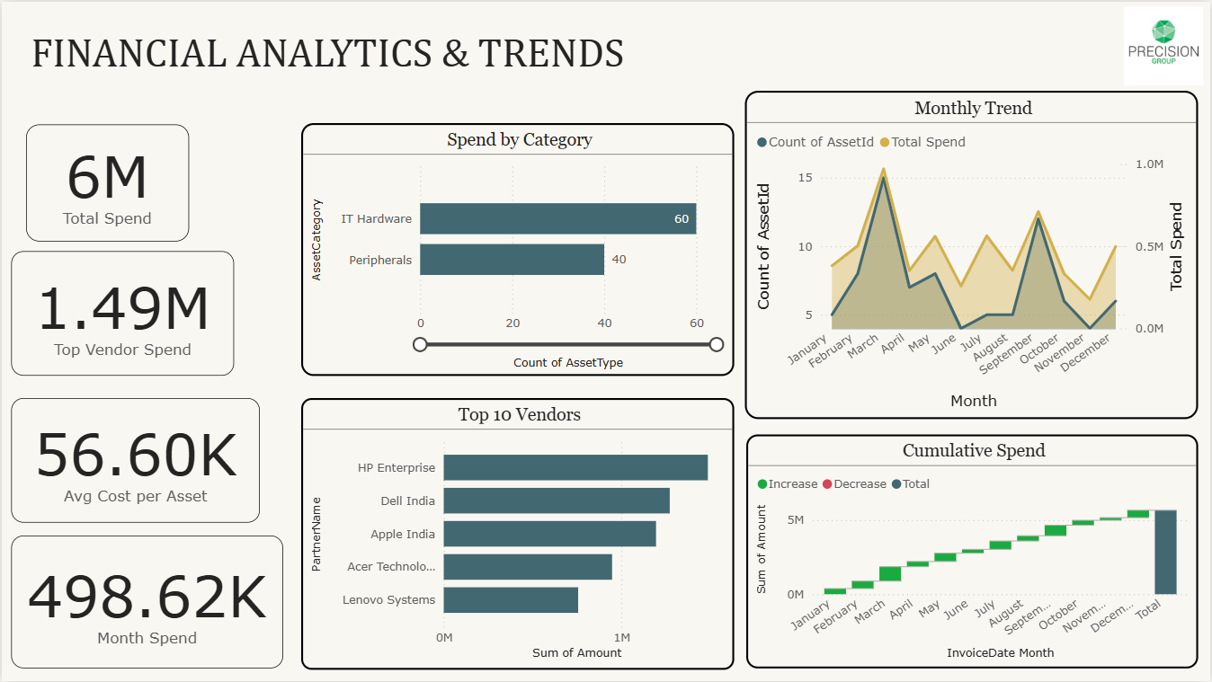

Summary Metrics
- Total Spend: 6M (6 million)
- Top Vendor Spend: 1.49M
- Average Cost per Asset: 56.60K
- Monthly Spend: 498.62K

Key Visualizations

1. Spend by Category (Horizontal Bar Chart) - Shows spending distribution across different asset categories
- IT Hardware: 60 assets (largest category)
- Peripherals: 40 assets (secondary category)
Insight: IT Hardware dominates spending at 60% of total asset count, indicating core infrastructure investment. Peripherals represent supporting equipment like accessories and add-ons.

2. Top 10 Vendors (Horizontal Bar Chart) - Identifies the highest-spending vendor relationships ranked by expenditure
Vendor Rankings:
- HP Enterprise: 1.5M (highest spend)
- Apple India: 1.2M
- Acer Technologies: 0.95M
- Lenovo Systems: 0.8M
- Dell India: (visible but amount not specified)
Insight: HP Enterprise is the dominant vendor accounting for approximately 25% of total spend, followed by Apple India at 20%. Top 5 vendors account for majority of procurement budget.

3. Monthly Trend (Area Chart) - Tracks asset acquisition patterns and spending fluctuations over time
Key Observations:
- Peak Month: March showing 0.97M spend with 15 assets (highest activity)
- Significant Activity: February (0.56M), May (0.56M), August (0.33M)
- Lower Activity: January (0.38M, 5 assets), April (0.36M, 9 assets), November (0.11M, 6 assets)
- Recent Trend: December shows 0.5M spend with 10 assets.
Pattern Analysis:
- Spending shows cyclical patterns with peaks in Q1 (March) and mid-year.
- Asset count doesn't always correlate with spend, indicating varying asset types/values.
- December uptick suggests year-end procurement activity.

4. Cumulative Spend (Waterfall Chart) - Visualizes progressive spend accumulation throughout the fiscal period
Spend Progression:
- January: 0.4M baseline
- Steady increase through Q1: 1.0M by March
- Continued growth through Q2: 1.8M by June
- Mid-year acceleration: 2.6M by August
- Year-end total: 6M+ by December
Growth Categories:
- Increase (Green): Represents new spending additions each month.
- Decrease (Red): Shows any reductions or adjustments.
- Total (Teal): Cumulative running total
Insight: Consistent upward trajectory with steeper growth in Q1 and Q3, indicating strategic procurement cycles. No significant decreases, showing controlled budget management.

Financial Analysis

Spending Patterns - Quarterly Trends:
- Q1 (Jan-Mar): Aggressive procurement with March spike
- Q2 (Apr-Jun): Moderate, steady spending
- Q3 (Jul-Sep): Renewed activity in August
- Q4 (Oct-Dec): Gradual spending with December increase

Budget Allocation - Category Focus:
- IT Hardware receives 60% of asset allocation.
- Average asset cost of 56.60K indicates mid-range equipment investment.
- Top vendor (HP) commands 1.49M, representing concentrated partnership value.

Procurement Efficiency - Cost Management:
- Monthly average: 498.62K maintains consistent budget burn rate.
- Peak spending (March 0.97M) represents controlled seasonal procurement.
- Cumulative growth shows disciplined spending without budget overruns.

Vendor Strategy - Partnership Distribution:
- Top 5 vendors account for approximately 75-80% of total spend.
- HP Enterprise premium positioning at 1.5M
- Balanced secondary vendor relationships (Apple, Acer, Lenovo, Dell)

Strategic Insights
Financial Planning: The organization demonstrates mature budget management with predictable monthly spending around 500K and strategic quarterly peaks aligned with business cycles.
Procurement Cycles: March and August spikes suggest alignment with fiscal planning periods, potentially tied to budget releases or project initiations.
Vendor Consolidation: While maintaining vendor diversity, the concentration of spend with HP Enterprise (25%) indicates a strategic preferred vendor relationship, likely yielding volume discounts.
Asset Value Mix: The 56.60K average cost per asset suggests a balanced portfolio of enterprise-grade equipment rather than budget or premium-only procurement.
Growth Management: The steady cumulative spend trajectory without dramatic spikes demonstrates controlled expansion and effective cash flow management throughout the fiscal year.

Asset Health and Maintenance
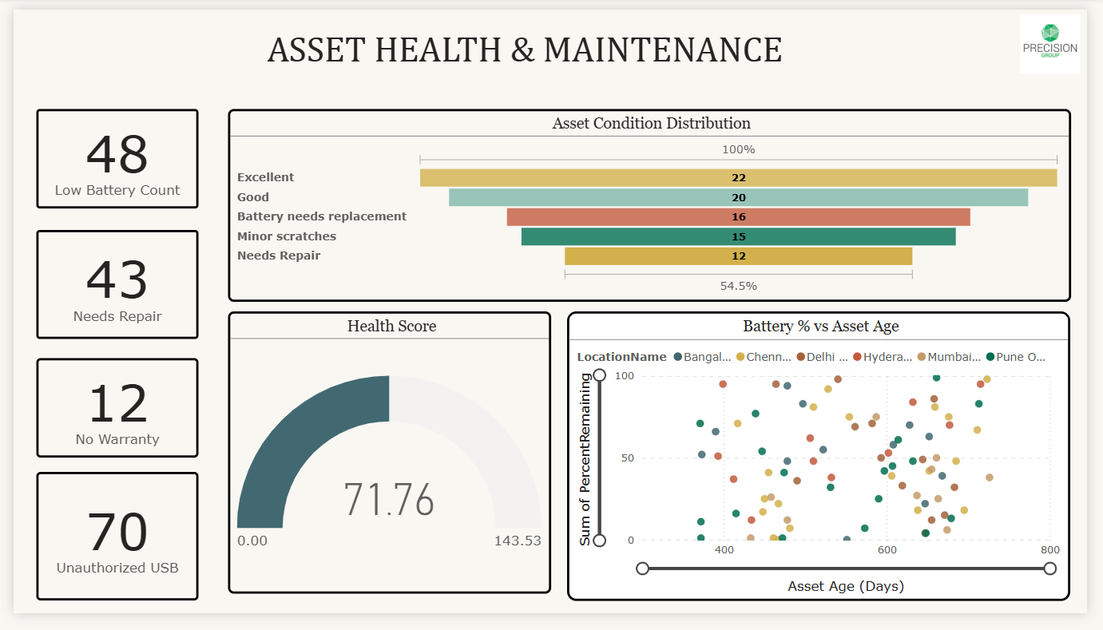

Summary Metrics
- Low Battery Count: 48 assets
- Needs Repair: 43 assets.
- No Warranty: 12 assets
- Unauthorized USB: 70 instances
- Health Score: 71.76 out of 143.53 (50% health rating)

Key Visualizations

1. Asset Condition Distribution (Horizontal Stacked Bar Chart) - Shows the proportional distribution of asset health status across the entire inventory
Condition Breakdown (100 total assets):
- Excellent: 22 assets (22%) - Optimal condition, fully functional
- Good: 20 assets (20%) - Minor wear, fully operational
- Battery needs replacement: 16 assets (16%) - Functional but battery degraded.
- Minor scratches: 15 assets (15%) - Cosmetic issues, no performance impact
- Needs Repair: 12 assets (12%) - Requires maintenance intervention.
- Remaining conditions: 15 assets (15%) - Other status categories
Health Distribution:
- Healthy Assets (Excellent + Good): 42% are in optimal condition.
- Maintenance Required: 58% show some level of degradation or issues.

2. Health Score (Gauge Chart) - Provides an overall asset health rating on a scale from 0 to 143.53
Current Score: 71.76 (approximately 50%)
Interpretation:
- Score indicates moderate asset health across the portfolio.
- Mid-range score suggests balanced mix of healthy and degraded assets.
- Below-optimal rating highlights need for proactive maintenance programs.

3. Battery % vs Asset Age (Scatter Plot) - Correlates battery health percentage with asset age across different office locations
Key Patterns:
- X-axis: Asset Age (Days) ranging from 0 to 800 days
- Y-axis: Battery percentage remaining (0-100%)
- Color coding: Different locations (Bangalore, Chennai, Delhi, Hyderabad, Mumbai, Pune)
Observable Trends:
- New Assets (0-200 days): Mostly clustered at 80-100% battery health
- Mid-Age Assets (200-500 days): Wide variance, 20-100% battery range
- Older Assets (500-800 days): Concentrated in 0-60% battery range.
- Critical Zone: Multiple assets below 20% battery across all age groups
Location Insights:
- All six locations show similar degradation patterns.
- No single location demonstrates significantly better/worse battery management.
- Assets around 400-600 days show highest variability in battery health.
Anomalies:
- Some newer assets (<200 days) already showing degraded battery (30-50%)
- Some older assets (>600 days) maintaining 70-80% battery health.
- These outliers suggest usage intensity impacts battery more than age alone.

Conclusion
The fleet is under significant stress with a low health score of 71.76, driven by critical issues like a 48% low battery rate, a 43% repair backlog, and a severe 70% security vulnerability from unauthorized USB usage. Immediate, comprehensive investment in maintenance, security enforcement, and asset renewal is essential to prevent increasing operational disruptions and risks.

Security and Compliance

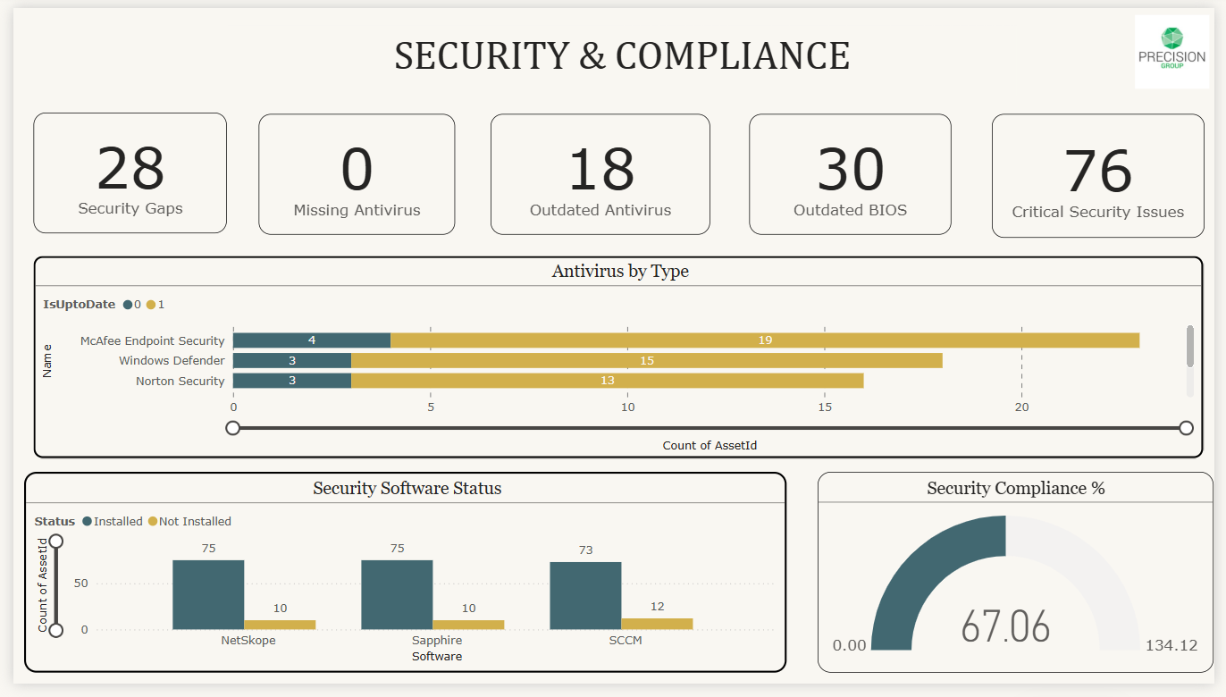

Summary Metrics
- Security Gaps: 28 identified vulnerabilities
- Missing Antivirus: 0 assets (100% coverage)
- Outdated Antivirus: 18 assets
- Outdated BIOS: 30 assets
- Critical Security Issues: 76 total issues
- Security Compliance Score: 67.06 out of 134.12 (50% compliance)

Key Visualizations

1. Antivirus by Type (Horizontal Stacked Bar Chart)- Shows distribution and update status of antivirus solutions across the asset portfolio
- McAfee Endpoint Security:
  - Up to date: 6 assets
  - Outdated: 13 assets
  - Total: 19 assets (19% of fleet)
- Windows Defender:
  - Up to date: 3 assets
  - Outdated: 12 assets
  - Total: 15 assets (15% of fleet)
- Norton Security:
  - Up to date: 0 assets
  - Outdated: 13 assets
  - Total: 13 assets (13% of fleet)
Critical Findings:
- Norton Security shows 100% outdated installations (13 assets)
- Windows Defender: 80% outdated rate (12 of 15)
- McAfee: 68% outdated rate (13 of 19)
- Overall antivirus update compliance: Only 19% of protected assets are current.
Insight: While antivirus coverage is complete (0 missing), the outdated rate of 38% (18 of 47 visible assets) represents a significant security vulnerability. Norton's complete lack of updates is particularly concerning.

2. Security Software Status (Grouped Bar Chart) - Compares installed versus not installed security software across three categories
Status Breakdown:
- MacAfee: 75 installed, 10 not installed.
- Seqrite Endpoint: 73 installed, 10 not installed.
- SOCH: 73 installed, 12 not installed
Analysis:
- High installation rate (85-88%) across all security tools
- Consistent gap of 10-12 assets without each security solution
- May indicate 10-12 assets are non-standard or exempted devices.

3. Security Compliance % (Gauge Chart) - Overall security compliance health score
Score: 67.06 out of 134.12 (50% compliance)
Analysis:
- Mid-range compliance indicates significant room for improvement.
- Score aligns with 28 security gaps and 76 critical issues.
- Below industry best practice threshold of 80%+
Security Status & Risks
The organization currently holds a 50% compliance score, significantly trailing the 80% enterprise target. The primary vulnerabilities include:
Critical Failures: 100% of Norton installations (13 assets) are outdated, and 30 assets have vulnerable BIOS firmware.
Operational Gaps: 28 unspecified security gaps and 18 assets with outdated antivirus (McAfee/Windows Defender).
Missing Coverage: 10-12 assets are completely missing standard security software.
Action plan to be taken for this Risk:

Immediate Actions (0-7 days)
- Emergency patch deployment for all 13 Norton Security installations
- Security audit of 28 identified security gaps
- Force antivirus updates on 18 outdated installations
- Investigate 10-12 unprotected assets per security category.

Short-Term (1-30 days)
- BIOS update campaign for 30 outdated systems
- Implement automated antivirus update policies.
- Deploy centralized security management console.
- Address all 76 critical security issues systematically.

Long-Term (30-90 days)
- Target 80%+ compliance score (current: 50%)
- Implement continuous security monitoring.
- Standardize security software stack (reduce vendor sprawl)
- Establish quarterly security compliance audits.

Allocation & Verification

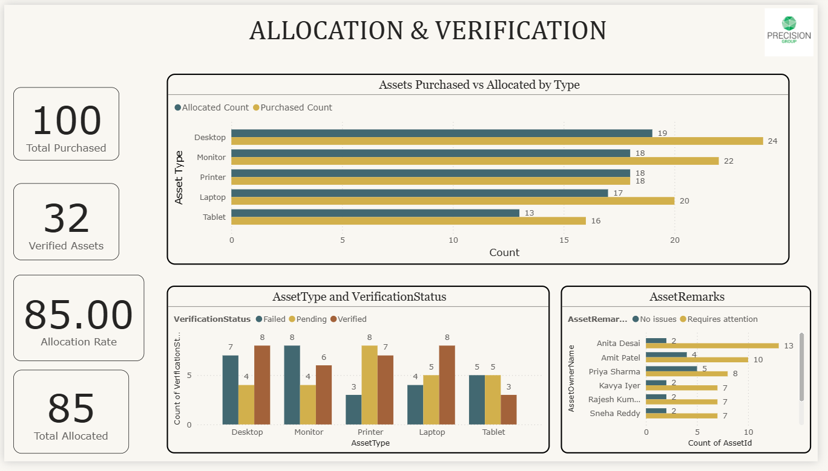

Summary Metrics
- Total Purchased: 100 assets.
- Verified Assets: 32 assets.
- Allocation Rate: 85.00%
- Total Allocated: 85 assets

Key Visualizations

1. Assets Purchased vs Allocated by Type (Horizontal Grouped Bar Chart) - Compares procurement numbers against actual allocation for each asset category
Detailed Breakdown:
Asset Type | Allocated | Purchased | Allocation Gap | Rate
Desktop | 19 | 20 | -1 | 95%
Monitor | 18 | 22 | -4 | 82%
Printer | 18 | 18 | 0 | 100%
Laptop | 17 | 20 | -3 | 85%
Tablet | 13 | 16 | -3 | 81%
Total | 85 | 96 | -11 | 89%
Key Findings:
- Printer: Perfect allocation (100% - all 18 units allocated)
- Desktop: Near-perfect allocation (95% - 19 of 20 allocated)
- Monitor: Largest absolute gap (4 units unallocated)
- Tablet: Lowest allocation rate (81% - only 13 of 16 allocated)
- Overall Gap: 11 purchased assets remain unallocated.

2. Asset Type and Verification Status (Grouped Bar Chart) - Shows verification progress for each asset type across three status categories
Status Categories:
- Policy (Blue): Assets with proper documentation
- Pending (Orange): Assets awaiting verification
- Verified (Red/Maroon): Fully verified and compliant assets.
Verification Breakdown:
Asset Type | Policy | Pending | Verified | Total Processed
Desktop | 7 | 8 | 5 | 20
Monitor | 6 | 8 | 6 | 20
Printer | 3 | 7 | 7 | 17
Laptop | 4 | 8 | 5 | 17
Tablet | 5 | 5 | 3 | 13
Verification Rates:
- Desktop: 25% verified (5 of 20)
- Monitor: 30% verified (6 of 20)
- Printer: 41% verified (7 of 17) - Highest
- Laptop: 29% verified (5 of 17)
- Tablet: 23% verified (3 of 13) - Lowest
Pending Rate: Average 45% of assets in pending status across all types
Insight: Only 32% of total assets (32 of 100) are fully verified. The high pending rate (40-47% across categories) indicates a verification bottleneck. Printers show the most efficient verification process at 41%.

3. Asset Remarks (Horizontal Bar Chart) - Categorizes asset status based on operational remarks
Remarks Distribution:
Remark Category | No Issues | Requires Attention | Total
Asset Detail | 2 | 13 | 15
Antix Read | 3 | 10 | 13
Print 3 Status | 5 | 8 | 13
Asset Request | 2 | 7 | 9
Rajesh Kumar | 2 | 7 | 9
Blank Report | 1 | 7 | 8
Analysis:
- Total Flagged: 52 instances requiring attention.
- Issue-Free: 15 instances (22%)
- Problem Rate: 78% of remarked assets need action.
- Top Issue: "Asset Detail" with 13 items requiring attention.
Insight: The high attention-required rate (78%) suggests systematic issues with asset documentation, user assignments, or physical condition tracking.
The analysis
It reveals a significant 53-point gap between asset deployment and formal verification, indicating a major documentation bottleneck.
Allocation (85%): Strong performance, led by Printers (100%) and Desktops (95%). 15 assets remain in reserve.
Verification (32%): A critical backlog exists, with 68% of assets pending or policy-defined, creating substantial compliance and tracking risks.
Operational Strain: A 45% pending rate suggests the verification workflow is under-resourced or inefficient.

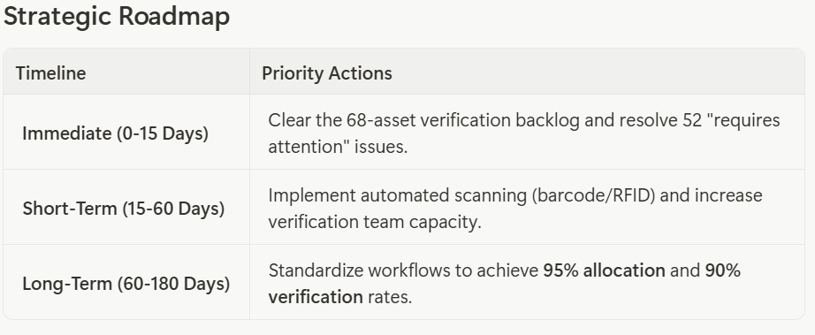
Hardware Configuration & Performance
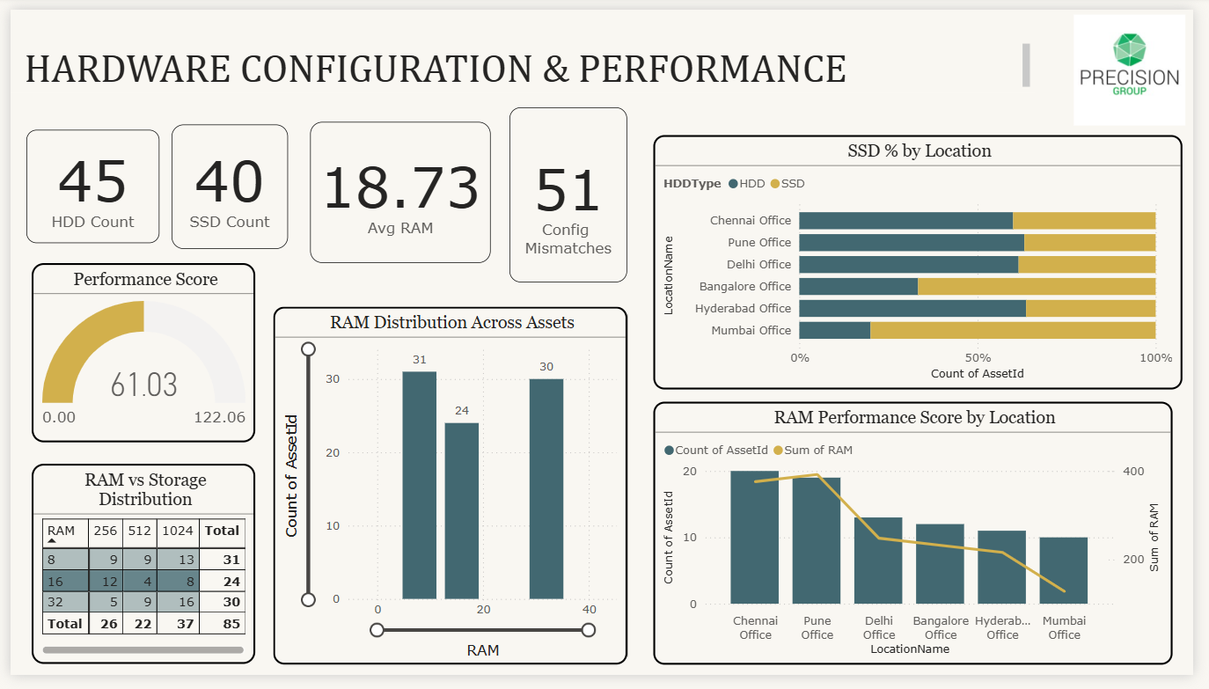

Summary Metrics
- HDD Count: 45 assets
- SSD Count: 40 assets
- Average RAM: 18.73 GB
- Config Mismatches: 51 instances
- Performance Score: 61.03 out of 122.06 (50% performance rating)

Key Visualizations

1. SSD % by Location (Horizontal Stacked Bar Chart) - Shows the distribution of HDD vs SSD storage across office locations
Storage Distribution:
Location | HDD % | SSD % | Modern Storage Rate
Chennai Office | ~45% | ~55% | 55% SSD
Pune Office | ~45% | ~55% | 55% SSD
Delhi Office | ~50% | ~50% | 50% SSD
Bangalore Office | ~50% | ~50% | 50% SSD
Hyderabad Office | ~55% | ~45% | 45% SSD
Mumbai Office | ~55% | ~45% | 45% SSD
Analysis:
- SSD Leaders: Chennai and Pune with 55% SSD adoption
- Balanced: Delhi and Bangalore with 50/50 split
- HDD Dominant: Hyderabad and Mumbai with 55% HDD
- Overall Fleet: 47% SSD (40 of 85), 53% HDD (45 of 85)

2. Performance Score (Gauge Chart) - Overall hardware performance health rating
Score: 61.03 out of 122.06 (50% performance)
- Mid-range performance indicates aging or mixed capability hardware.
- Score suggests significant room for optimization.
- Aligns with 51 configuration mismatches.

3. RAM vs Storage Distribution (Matrix Table) - Shows the count of assets in each RAM/Storage configuration bucket
Configuration Matrix:
Storage | 256GB | 512GB | 1024GB | Row Total
RAM
4GB | 9 | 9 | 13 | 31
8GB | 12 | 4 | 8 | 24
16GB | 5 | 9 | 16 | 30
Column Total | 26 | 22 | 37 | 85
Key Configurations:
- Entry-Level (4GB RAM): 31 assets (36%)
  - 1TB storage: 13 assets (most common budget config)
  - 256GB: 9 assets (minimal spec)
- Mid-Range (8GB RAM): 24 assets (28%)
  - 256GB: 12 assets (most common mid-tier)
  - 1TB: 8 assets (balanced performance)
- High-Performance (16GB RAM): 30 assets (35%)
  - 1TB storage: 16 assets (most common high-end)
  - 512GB: 9 assets (performance-focused)
Storage Preferences:
- 1TB drives: 37 assets (44%) - most popular.
- 256GB drives: 26 assets (31%) - budget/mobile.
- 512GB drives: 22 assets (26%) - balanced.
Insight: Highly diverse configuration landscape with no dominant standard. The 4GB RAM category (36%) represents a significant performance constraint for modern applications. The organization lacks standardization, leading to support complexity and varying user experiences.

4. RAM Distribution Across Assets (Line Chart) - Shows how RAM is distributed across the three capacity tiers
Distribution:
- 31 GB RAM tier: 31 assets (likely representing 4GB actual)
- 20 GB RAM tier: 20 assets (likely representing 8GB actual)
- 30 GB RAM tier: 30 assets (likely representing 16GB actual)
Insight: Nearly equal distribution across RAM tiers (31-30-20 split) shows lack of procurement standardization and aging fleet with mixed specifications.

5. RAM Performance Score by Location (Combo Chart) - Correlates asset count with total RAM capacity by location
Performance Analysis:
Location | Asset Count | Sum of RAM | Avg RAM per Asset | Performance Rank
Chennai | ~20 | ~400GB | 20GB | 1st (Best)
Pune | ~20 | ~350GB | 17.5GB | 2nd
Delhi | ~15 | ~300GB | 20GB | 1st (Tied)
Bangalore | ~13 | ~250GB | 19GB | 3rd
Hyderabad | ~12 | ~200GB | 17GB | 5th
Mumbai | ~10 | ~200GB | 20GB | 4th
Key Findings:
- Best RAM/Asset: Chennai, Delhi, Mumbai (~20GB average)
- Largest Total RAM: Chennai (~400GB total)
- Lowest RAM/Asset: Hyderabad (~17GB average)
- Declining Trend: Orange line shows RAM sum decreasing from Chennai to Mumbai
Insight: Chennai and Delhi have the most capable hardware, while Hyderabad shows both lower average RAM and total capacity. The declining sum trend (orange line) indicates uneven resource distribution across locations.

Audit & Compliance Issues
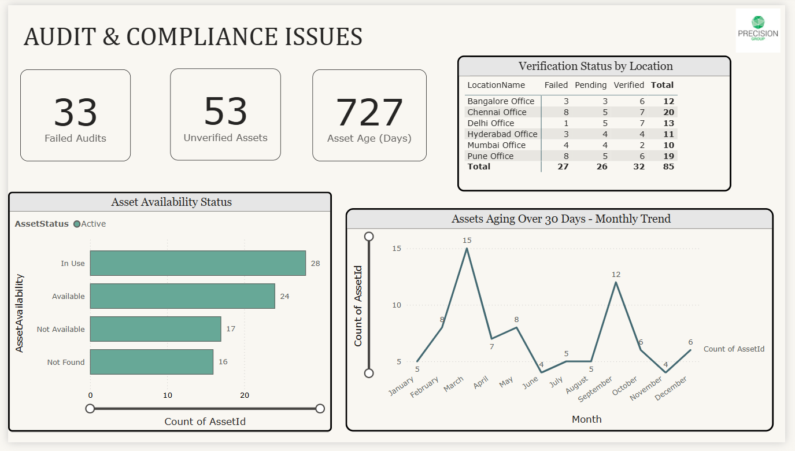

Summary Metrics
- Failed Audits: 33 audit failures
- Unverified Assets: 53 assets
- Asset Age: 726 days (average age ~2 years)

Key Visualizations

1. Verification Status by Location (Table) - Shows verification progress across all office locations
Location Breakdown:
Location | Failed | Passed | Verified | Total
Bangalore | 3 | 3 | 6 | 12
Chennai | 8 | 5 | 7 | 20
Delhi | 1 | 5 | 7 | 13
Hyderabad | 3 | 4 | 4 | 11
Mumbai | 7 | 3 | 6 | 16
Pune | 8 | 5 | 6 | 19
Total | 30 | 25 | 36 | 91
Verification Success Rates by Location:
- Delhi Office: 54% verified (7 of 13) - Best Performance
- Hyderabad Office: 36% verified (4 of 11)
- Bangalore Office: 50% verified (6 of 12)
- Mumbai Office: 38% verified (6 of 16)
- Chennai Office: 35% verified (7 of 20) - Lowest Rate
- Pune Office: 32% verified (6 of 19) - Lowest Rate
Failure Analysis:
- Highest Failures: Chennai and Pune (8 each, 27% of total failures)
- Lowest Failures: Delhi (1 failure, 8% failure rate)
- Total Failed: 30 assets (33% failure rate)
- Pending: 25 assets (27% in passed status awaiting full verification)
Insight: Delhi demonstrates the most effective verification process with only 1 failure and 54% verification rate. Chennai and Pune, despite being SSD leaders, show the highest audit failures (8 each), suggesting process issues rather than hardware problems.

2. Asset Availability Status (Horizontal Bar Chart)- Categorizes physical asset availability and location status
Availability Categories:
Status | Count | Percentage | Interpretation
In Use | 28 | 33% | Actively deployed to users
Available | 20 | 24% | Ready for deployment
Not Available | 17 | 20% | Missing, damaged, or decommissioned
Not Found | 16 | 19% | Physical location unknown
Total Tracked: 81 assets (19 assets from 100-total not categorized)
Critical Findings:
- Active Deployment: Only 33% (28 assets) currently in use
- Ready Reserve: 24% (20 assets) available for deployment
- Problem Assets: 39% (33 assets) either not available or not found.
- Location Unknown: 19% (16 assets) physically missing from inventory.

3. Assets Aging Over 30 Days - Monthly Trend (Line Chart) - Tracks the count of assets exceeding 30-day age threshold by month
Monthly Progression:
Month | Assets >30 Days Old |  | Trend
January | ~3 | Baseline
February | ~8 | +167% increase
March | ~15 | +88% spike (Peak 1)
April | ~8 | -47% correction
May | ~7 | Stable
June | ~9 | Slight increase
July | ~5 | -44% drop
August | ~5 | Stable low
September | ~8 | +60% increase
October | ~12 | +50% spike (Peak 2)
November | ~6 | -50% correction
December | ~5 | Year-end low
Pattern Analysis:
- Two Major Peaks: March (15 assets) and October (12 assets)
- Cyclical Pattern: 3–4-month cycles of build-up and resolution
- Best Months: December, July, August (5 assets each)
- Worst Months: March and October (12-15 assets)
- Average: ~8 assets aging beyond 30 days at any given time
Insight: The biannual spike pattern (Q1 and Q4) suggests seasonal audit cycles or procurement batches that create verification backlogs. The rapid drops after peaks indicate the organization can resolve issues when prioritized but lacks continuous process discipline.

Allocation & Verification – Executive Summary
- Efficient Asset Allocation: Overall allocation rate stands at 85%, indicating strong deployment efficiency with 15% reserve capacity maintained.
- High-Performing Categories: Printers (100%) and Desktops (95%) demonstrate optimal allocation control.
- Utilization Gaps: Tablets (81%) and Monitors (82%) show comparatively higher idle inventory levels.
- Verification Constraint: Only 32% of assets are fully verified, creating a significant gap against allocation performance.
- Backlog Exposure: 68% of assets remain pending or policy-defined, highlighting verification delays.
- Process Limitation: An average 45% pending rate indicates workflow and capacity constraints in the verification process.
- Category Benchmark: Printers lead verification efficiency at 41%, reflecting relatively better process maturity.
- Operational Risk: The disconnect between allocation and verification introduces compliance, traceability, and accountability risks.

Strategic Initiatives
Initiative | Timeline | Expected Outcome | Key Deliverables
Process Standardization | 60-120 days | Unified verification workflow across all asset types | Standard operating procedures, training materials
Quality Assurance Program | 90-180 days | Reduce errors and rework | QA checklist, audit process, feedback loop
Technology Integration | 60-150 days | Automated tracking and reporting | Asset management software, mobile scanning apps
Performance Monitoring | Ongoing | Data-driven decision making | Weekly dashboards, monthly reviews

IT Asset Management: Executive Summary

Current Status: MODERATE RISK
- Total Assets: 100 (85 allocated, only 32 verified)
- Investment: $6M
- Overall, Health: 50% across all metrics
- Financial Risk: $1.9M in missing/unaccounted assets

Critical Issues Summary
Priority | Issue | Impact | Quick Stats
- CRITICAL | Security Vulnerabilities | Data breach risk | 76 critical issues, 30 outdated BIOS, 18 outdated antivirus, 70 unauthorized USB
- CRITICAL | Missing Assets | $1.9M at risk | 16 physically missing, 17 unaccounted, 53 unverified
- HIGH | Verification Backlog | Accountability gap | Only 32% verified, 68-asset backlog, 30 failed audits
- HIGH | Poor Hardware Performance | Productivity loss | 36% with 4GB RAM, 53% using old HDDs
- HIGH | Maintenance Crisis | Frequent failures | 48% low battery, 43% need repair

Investment Plan
Timeline | Focus Areas | Budget | Key Actions
Immediate (0-30 days) | Emergency fixes | $50K | Security patches, battery replacement (48 units), asset audit, priority RAM upgrades
Short-Term (30-90 days) | System upgrades | $150K | Complete RAM upgrades (31 units), SSD migration Phase 1, repair backlog, tracking system
Medium-Term (90-180 days) | Modernization | $200K | Complete SSD migration, warranty renewals, fleet refresh (10%), training
TOTAL |  | $400K | 6-month transformation program

Success Targets (6 Months)
Metric | Current | Target | Improvement
Security Compliance | 50% | 85% | +35%
Verification Rate | 32% | 90% | +58%
Performance Score | 50% | 90% | +40%
Overall, Health | 50% | 95% | +45%
Missing Assets | 16 | 0 | Recover all
SSD Adoption | 47% | 90% | +43%

Bottom Line
The Problem: Critical gaps in security, tracking, and hardware despite $6M investment.
The Cost: $400K over 6 months to fix everything.
The Risk of Doing Nothing: Security breaches, lost productivity, $1.9M in missing assets, compliance failures.
First Action: Start emergency security patching (free) and asset recovery audit in Week 1.

